**Program**

//Programmer Name: Sharvil Prabhudesai 20co41

#program Title: 1.Display greet message using the system time.

echo "Enter your name :"

read name

t=`date +%H`

h=`date +%M`

if [ $t -ge 0 -a $t -lt 12 ]

then

echo "GOOD MORNING $name"

elif [ $t -ge 12 -a $t -lt 17 ]

then

echo "GOOD AFTERNOON $name"

elif [ $t -ge 17 -a $t -lt 20 ]

then

echo "GOOD EVENING $name"

else

echo "GOOD NIGHT $name"

fi

**Output**

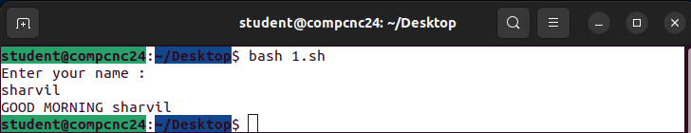

**Program**

//Programmer Name: Sharvil Prabhudesai 20co41

#Program Title: 2. Find the factorial of a given number.

echo "Please enter the number : "

read fnum

fact=1

for ((i=$fnum;i>0;i--))

do

fact=`expr $i \* $fact`

done

echo "Factorial of $fnum = $fact "

**Output**

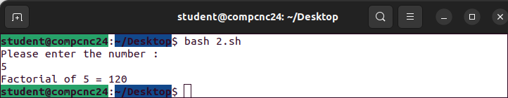

**Program**

//Programmer Name: Sharvil Prabhudesai 20co41

#program Title:3. Generate the fibonacci series for the number of terms entered by the user

echo "enter the value of n"

read n

a=0

b=1

echo "Fobonnaci Series :"

for(( i=1 ; i<= $n ; i++ ))

do

c=`expr $a + $b`

echo -n "$a "

a=$b

b=$c

done

**Output**

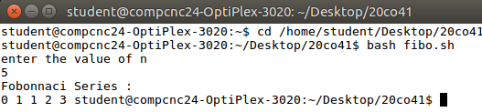

**Program**

//Programmer Name: Sharvil Prabhudesai 20co41

#program Title: 4. To print the number table.

echo "enter the value of n"

read n

echo "Table of $n:"

for(( i=1 ; i<= 10 ; i++ ))

do

c=`expr $n \* $i`

echo "$n * $i= $c "

done

**Output**

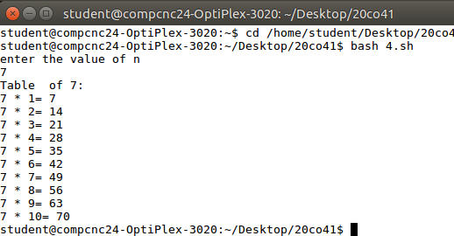

**Program**

//Programmer Name: Sharvil Prabhudesai 20co41

#program Title:5. To display square of first 20 numbers.

echo "Square of first 20 numbers is :"

for(( i=1 ; i<= 20 ; i++ ))

do

c=`expr $i \* $i`

echo " square of ($i)= $c "

done

**Output**

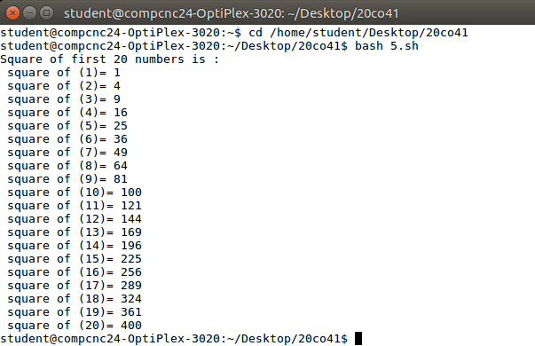

**Program**

//Programmer Name: Sharvil Prabhudesai 20co41

#program Title:6. To print the largest of 3 numbers entered by the user.

echo -n "Enter the first number:"

read a

echo -n "Enter the second number:"

read b

echo -n "Enter the third number:"

read c

echo "Largest number from a=$a,b=$b,c=$c is "

if [ $a -ge $b ]

then

if [ $a -ge $c ]

then

echo -n "$a"

else

echo -n "$c"

fi

else

if [ $b -ge $c ]

then

echo -n "$b"

else

echo -n "$c"

fi

fi

echo ""

echo ""

**Output**

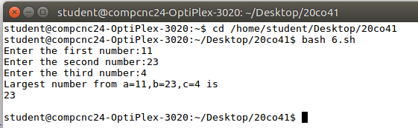

**Program**

//Programmer Name: Sharvil Prabhudesai 20co41

#program Title: 7. To reverse a number.

echo "enter a number:"

read n

echo "reversal of a number is :"

d=0

reversal=0

while [ $n -gt 0 ]

do

d=`expr $n % 10`

reversal=`expr $reversal \* 10 + $d`

n=`expr $n / 10`

done

echo "$reversal"

**Output**

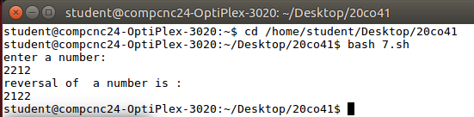

**Program**

//Programmer Name: Sharvil Prabhudesai 20co41

#program Title:8. To reverse a string.

echo "enter a string:"

read n

revstr=`echo $n | rev`

echo "$revstr"

**Output**

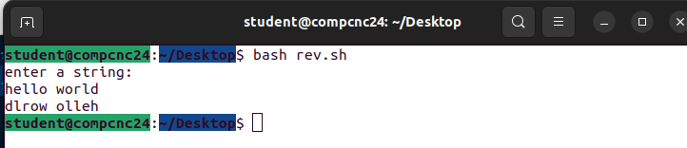

**Program**

//Programmer Name: Sharvil Prabhudesai 20co41

#program Title:8. To reverse a string

echo "Enter a String"

read input

reverse=""

length=${#input}

for (( i=$length-1; i>=0; i-- ))

do

rev="$rev${input:$i:1}"

done

echo "Reversal of a string : $rev"

echo " "

**Output**

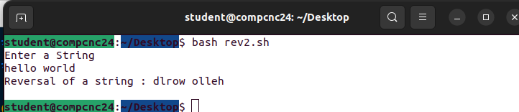

**Program**

//Programmer Name: Sharvil Prabhudesai 20co41

#program Title :9. Check whether the entered number is odd or even.

echo "Enter the value of n"

read n

echo " "

n1=`expr $n % 2`

if [ $n1 -ne 0 ]

then

echo "$n is odd number"

else

echo "$n is even number"

fi

**Output**

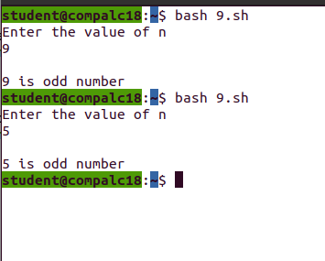

**Program**

//Programmer Name: Sharvil Prabhudesai 20co41

#program Title:10. Check Whether given year is leap year or not.

echo "Enter a year: "

read year

#leap year if perfectly divisible by 400

if [ `expr $year % 400` -eq 0 ]

then

echo "$year is a leap year."

elif [ `expr $year % 100` -eq 0 ]

then

echo "$year is not a leap year."

elif [ `expr $year % 4` -eq 0 ]

then

echo "$year is a leap year."

else

echo "$year is not a leap year."

fi

**Output**

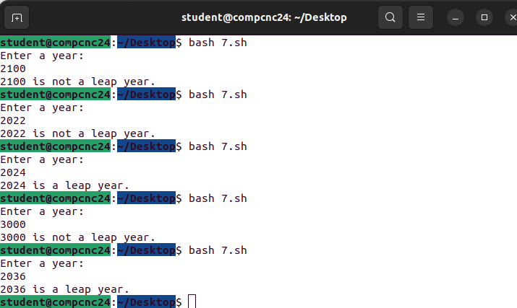

**Program**

//Programmer Name: Sharvil Prabhudesai 20co41

#program name :11. To print all the prime numbers less than 20.

i=2

while [ $i -lt 20 ]

do

count=0

for (( k=1; k<=$i; k++ ))

do

if [ `expr $i % $k` -eq 0 ]

then

count=`expr $count + 1`

fi

done

if [ $count -le 2 ]

then

echo "We got prime numbers: $i"

fi

i=`expr $i + 1`

done

**Output**

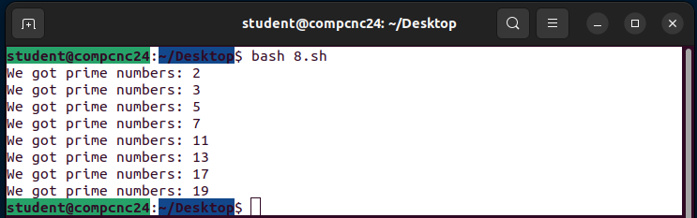

**Program**

//Programmer Name: Sharvil Prabhudesai 20co41

#program Title :12. if the entered string is palindrome or not

echo "Enter a String"

read input

reverse=""

length=${#input}

for (( i=$length-1; i>=0; i-- ))

do

rev="$rev${input:$i:1}"

done

if [ $input == $rev ]

then

echo "$input is palindrome"

else

echo "$input is not palindrome"

fi

**Output**

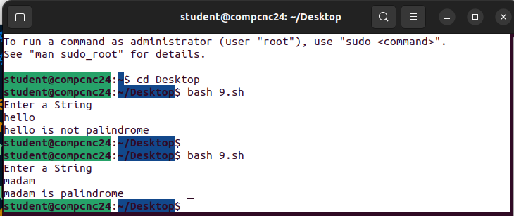

**Program**

//Programmer Name: Sharvil Prabhudesai 20co41

#program Title:13. switch case print the capitals given the state name.

echo "enter state name:"

read state

case "$state" in

[Aa]ndhra[Pp]radesh ) echo " state is : Hyderabad";;

[Aa]runachal[Pp]radesh) echo "state is :Itanagar";;

[Aa]ssam) echo "state is :Dispur";;

[Bb]ihar) echo "state is :Patna";;

[Cc]hhattisgarh) echo "state is :Naya Raipur";;

[Gg]oa) echo "state is :Panaji";;

[Gg]ujarat) echo "state is :Gandhinagar";;

[Hh]aryana) echo "state is :Chandigarh";;

[Hh]imachal[Pp]radesh) echo "state is :Shimla (Summer),Dharamsala (Winter)";;

[Jj]harkhand) echo "state is :Ranchi";;

[Kk]arnataka) echo "state is :Bangalore";;

[Kk]erala) echo "state is :Thiruvananthapuram";;

[Mm]adhya[Pp]radesh) echo "state is :Bhopal";;

[Mm]aharashtra) echo "state is :Mumbai ";;

[Mm]anipur) echo "state is :Imphal";;

[Mm]eghalaya) echo "state is :Shillong";;

[Mm]izoram) echo "state is :Aizawl";;

[Nn]agaland) echo "state is :Kohimas";;

[Oo]disha) echo "state is :Bhubaneshwar";;

[Pp]unjab) echo "state is :Chandigarh";;

[Rr]ajasthan) echo "state is :Jaipur";;

[Ss]ikkim) echo "state is :Gangtok";;

[Tt]amil[Nn]adu) echo "state is :Chennai";;

[Tt]elangana ) echo "state is :Hyderabad";;

[Tt]ripura) echo "state is :Agartala";;

[Uu]ttarakhand) echo "state is :Gairsain (Summer),Dehradun (Winter)";;

[Uu]ttar[Pp]radesh ) echo "state is :Lucknow";;

[Ww]est[Bb]engal) echo "state is :Kolkata";;

*) echo "Invalid Input";

esac

**Output**

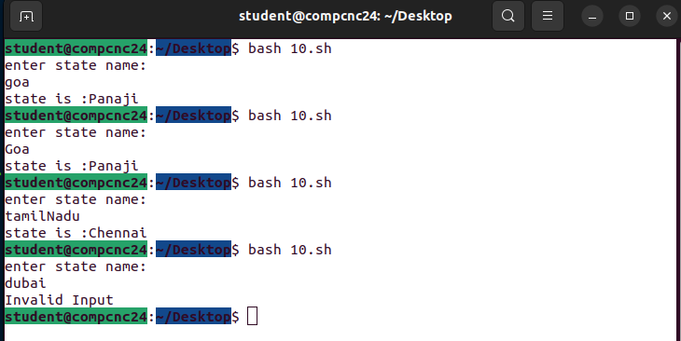

**Program**

//Programmer Name: Sharvil Prabhudesai 20co41

#program Title:14. Write shell script to generate following series: 20, 22, 18, 20, 16, 18, 14, 16.

sum=20

sum1=0

echo "The Series is"

for (( i=1; i<=4;i++ ))

do

sum1=$sum

echo -n "$sum1 "

sum1=`expr $sum1 + 2`

echo -n "$sum1 "

sum=`expr $sum - 2`

done

echo " "

**Output**

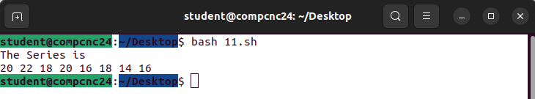

**Program**

//Programmer Name: Sharvil Prabhudesai 20co41

#program Title :15. Append content to a file provided file name exists and it has write permission.

echo "enter the contents :"

cat >> file1.txt

date >> file1.txt

**Output**

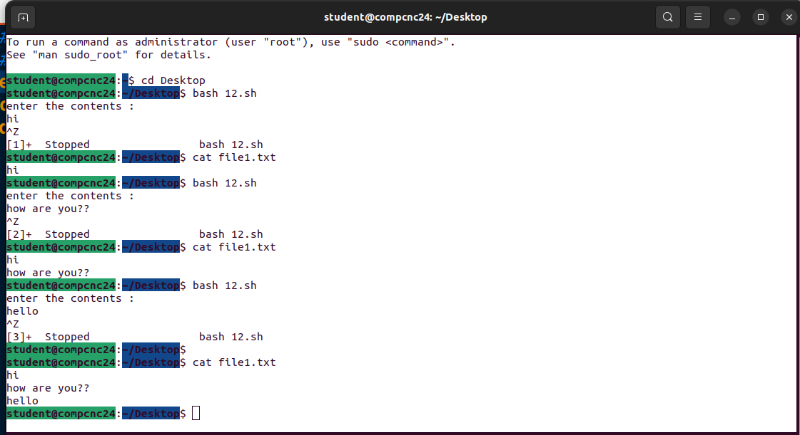

**Program**

//Programmer Name: Sharvil Prabhudesai 20co41

#program name :16. Generate the series: 1,3,2,4,3,5,4,6,.....

sum=1

sum1=0

echo "The Series is"

for (( i=1; i<20;i++ ))

do

sum1=$sum

echo -n "$sum1 "

sum1=`expr $sum1 + 2`

echo -n "$sum1 "

sum=`expr $sum + 1`

done

echo " "

**Output**

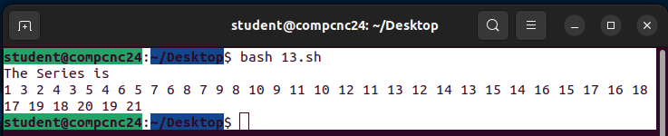

**Program**

//Programmer Name: Sharvil Prabhudesai 20co41

#program name :17. shell script to prompt user to enter 2 numbers and perform various #arithmetic operations using switch statement.

echo -n "Enter First Number : "

read num1

echo -n "Enter Second Number : "

read num2

echo ""

echo " Menu "

echo "Enter 1 : For Addition "

echo "Enter 2 : For Subtraction"

echo "Enter 3 : For Multiplication "

echo "Enter 4 : For Division"

read choice

case "$choice" in

1 ) echo "$num1 + $num2=" `expr $num1 + $num2`;;

2 ) echo "$num1 - $num2="`expr $num1 - $num2`;;

3 ) echo "$num1 * $num2="`expr $num1 \* $num2`;;

4 ) echo "$num1 / $num2="`expr $num1 \/ $num2`;;

* ) echo "Invalid"

esac

**Output**

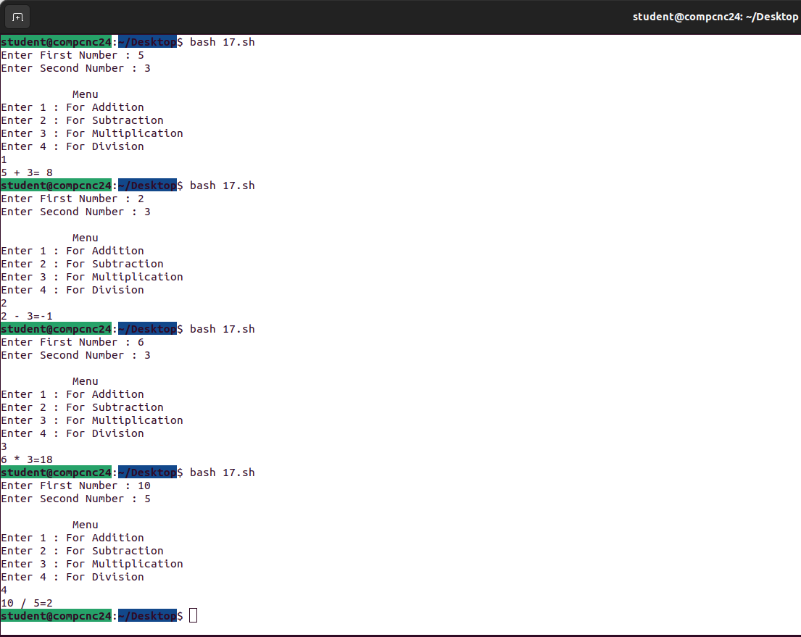

**Program**

//Programmer Name: Sharvil Prabhudesai 20co41

#program Title : 18. To sort given numbers in descending order

echo "enter total number of elements :"

read n

echo "enter Numbers in array:"

for (( i = 0; i < $n; i++ ))

do

read nos[$i]

done

echo " Array Before Sorting:"

for (( i = 0; i < $n; i++ ))

do

echo "nos[$i]=${nos[$i]}"

done

echo " "

for (( i = 0; i < $n ; i++ ))

do

for (( j = $i; j < $n; j++ ))

do

if [ ${nos[$i]} -lt ${nos[$j]} ]; then

temp=${nos[$i]}

nos[$i]=${nos[$j]}

nos[$j]=$temp

fi

done

done

echo "Array After Sorting "

for (( i=0; i < $n; i++ ))

do

echo "nos[$i]=${nos[$i]}"

done

**Output**

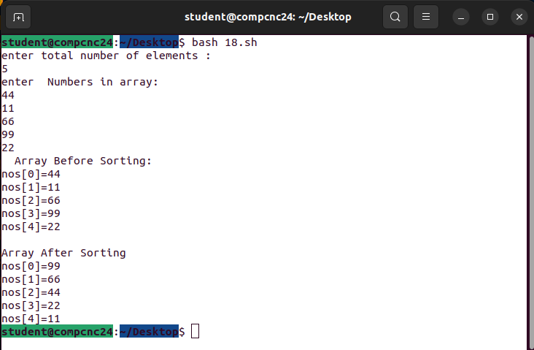

**Program**

//Programmer Name: Sharvil Prabhudesai 20co41

#program Title :.19. Display the following patterns :

# * * * * *

# * * * *

# * * *

# * *

# *

# 1 2 3 4

# 2 3 4

# 3 4

# 4

# 1

# 2 2

# 3 3 3

# 4 4 4 4

for (( i=5; i>=1; i-- ))

do

for (( j=1; j<=$i; j++ ))

do

echo -n "*"

done

echo""

done

echo ""

for (( i=1; i<=4; i++ ))

do

for (( j=$i; j<=4; j++ ))

do

echo -n "$j"

done

echo " "

done

echo " "

for (( i=1; i<=4; i++ ))

do

for (( j=1; j<=$i; j++ ))

do

echo -n "$i"

done

echo " "

done

**Output**

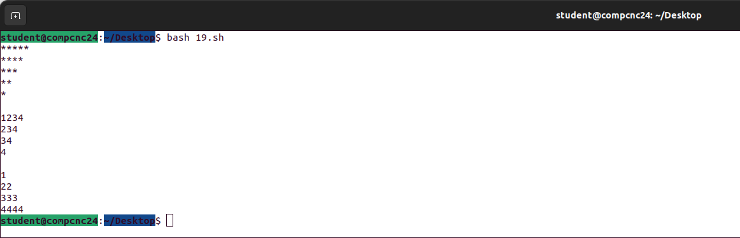

**Program**

//Programmer Name: Sharvil Prabhudesai 20co41

#program Title :15. Append content to a file provided file name exists and it has write permission.

echo "enter a file name:"

read fname

if [ -f "$fname" ]

then

if [ -w "$fname" ]

then

echo "enter the contents to append to a file "

cat >> $fname

else

echo "no write permission"

fi

else

echo "File not existing"

fi

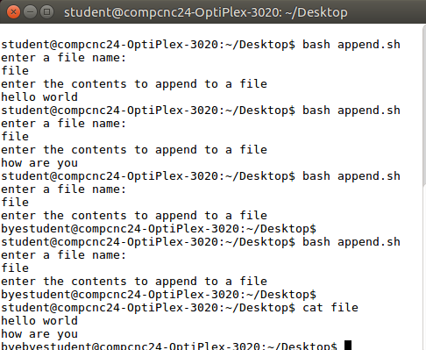

**Program**

//Programmer Name: Sharvil Prabhudesai 20co41

#program Title: 7. To reverse a number.

echo "Enter a string:"

read str

echo "Entered string is: $str"

len=`echo -n "$str"|wc -c`

rev=""

echo "Length of the string is : $len"

while [ $len -gt 0 ]

do

rev=$rev`echo $str|cut -c $len`

len=`expr $len - 1`

done

echo -n $rev

echo " "

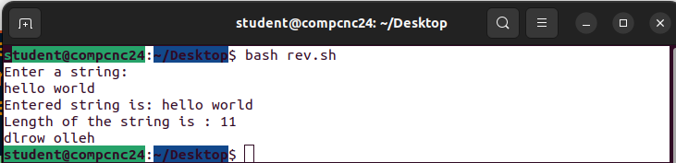

**Program**

//Programmer Name: Sharvil Prabhudesai 20co41

#program Title :12. if the entered string is palindrome or not

echo "Enter a string:"

read str

echo "Entered string is: $str"

len=`echo -n "$str"|wc -c`

rev=""

echo "Length of the string is : $len"

while [ $len -gt 0 ]

do

rev=$rev`echo $str|cut -c $len`

len=`expr $len - 1`

done

if [ $str == $rev ]

then

echo "string is palindrome"

else

echo "string is not palindrome"

fi

